**Animal Aerodynamics**

## Description

How can nature influence the way we design aircraft? In this module, students will explore the creation of aircraft inspired by animals. Participants will learn about various types of biomimicry techniques employed by engineers and then devise models of their own using paper and other crafting materials to see how they fly. Additionally, students will build an apparatus to test their designs and gain further understanding about aerodynamics and the ways that we can continue to improve the efficiency of air travel.

The learning goals for this activity include

* Basic principles of aerodynamics including lift, drag, turbulence, and laminar flow
* Search for patterns in nature and discover alternative ways to construct aircraft
* Construct basic test chamber for testing aircraft and consider the factors that determine success including stability and efficiency

## Schedule

### Day 1

9:30-9:45 (15 minutes)

Introductions

Game: **Matching game to identify human-made structures and items inspired by animals and nature**

9:45-10:05 (20 minutes)

Interactive Discussion: **What is biomimicry? Why is it important? Can inspiration from nature change the way we fly?**

10:05-10:15 (10 minutes)

Challenge: **Paper Airplane Distance**

10:15-10:30 (15 minutes)

Break

10:30-10:50 (20 minutes)

Discussion and Activity: [**Fluid Dynamics Simulation**](http://physics.weber.edu/schroeder/fluids/)

10:50-11:05 (15 minutes)

Tutorial: **Creating Body (Fuselage) of Animal-Inspired Plane**

11:05-11:55 (50 minutes)

Activity: **Creating Body (Fuselage) of Animal-Inspired Plane**

11:55-12:00 (10 minutes)

Recap and Clean-up

### Day 2

9:30-9:45 (15 minutes)

Introductions, Recap

9:45-10:00 (15 minutes)

Tutorial: **Building a Wind Tunnel**

10:00-10:15 (15 minutes)

Activity: **Building a Wind Tunnel**

10:15-10:30 (15 minutes)

Break

10:30-11:15 (35 minutes)

Activity: **Building a Wind Tunnel and Testing Fuselage in Wind Tunnel**

11:15-11:45 (30 minutes)

Activity: **Adding Wings and Testing Full Plane in Wind Tunnel**

11:45-12:00

Presentations and Clean-up

## Lesson Guide

### Day 1 - Shapes from Nature

Materials:

Laptops

Vinyl Cutter/Laser Cutter

Plywood

100-Grit Sandpaper

Overview:

The lesson begins with an introduction to the idea that nature inspires many of the design choices that humans have made with regard to the things that we make and build. When thinking about transportation, we often want to think about the way that we can make designs the best they can be in a certain area. These might include speed, efficiency, appearance, and others, and often we look to the ways that different organisms have become specialized through their evolution to get ideas from them. The students will be told that they will be focusing on air travel and specifically, airplanes. However, before they can think about how to make the best plane, they’ll need to understand more about aerodynamics and determine a way to test if their plane is “good” or not.

Students will be able to draw and use images of animals that will be converted into physical form after being cut using a laser cutter. Students will work in pairs for this activity with each team constructing two planes.

**Game: Matching game to identify human-made structures and items inspired by animals and nature**

Start the class off with a quick icebreaker having everyone go around the room, saying their name and favorite animal. Following the introductions, have the tables become groups and challenge the groups to correctly match the human-made structures and items with the animals and nature that inspired or helped produced them. Do this by passing out pre-printed copies of the pairs to each table (print at least 6 sets). Use the slides in the “Biomimicry Matching Game” presentation to reveal the answers.

**Interactive Discussion: What is biomimicry?**

For this discussion, use the slides in the “Animal Aerodynamics Day 1” presentation. Introducing the concept of biomimicry, have the students try to make a definition based on the matching game they just played. After revealing the technical definition from biomimicry.org, switch to the simplified version, reading

“Biomimicry is a way of copying what works in nature and using it to find solutions to the problems that humans face.”

With the idea of nature inspiring the production of new human inventions, the conversation will shift as you move the conversation towards the idea of travel and, eventually, flight.

“Birds have obviously had an impact on the design of planes and jets, but have other organisms impacted the way humans fly?”

Reveal the Airbus Beluga, a cargo plane taking cues from the Beluga whale. In the beluga plane video, show opening at the start of video to show how the cargo bay opens like a beluga whale’s mouth. Then, increase speed to 2x and skip to 1:09 as the plane parts are loaded.

**Challenge: Paper Airplane Distance**

10 minutes before the break, challenge the students to fold a paper airplane they think will go the farthest from one side of the classroom to the other within 5 minutes. Before passing out the paper, inform them that they will only have **one chance** to throw it, no practice. If they throw it before the challenge starts, they are disqualified. Pass out the paper, and time the students for five minutes. Ensure that they’ve written a name on the plane. When the time is up, have the class go to one side of the classroom, line up, and on the count of three, throw their airplanes across the room simultaneously. Have them stay on the side of room while you find the plane you deem the winner. Before releasing them for their break, ask them to consider why the plane that went the farthest did so. Then they can collect their planes and go outside for their break but hold onto the winner’s plane.

**Discussion and Activity: Fluid Dynamics Simulation**

After getting settled, ask the class to consider why the winning plane went the furthest. Was it the strength of the throw? The shape? Luck? Remind the students that as the planes fly, they are interacting with the air, a fluid. As the plane moves through it, the air pushes back on the plane, and the aircraft that can get pushed back the least by the molecules of air move the the fluid more easily. Demonstrate this concept using the [fluid dynamics simulation](http://physics.weber.edu/schroeder/fluids/). Since air is a fluid, we can use this tool to show how the air is affected by different shapes. (Use this moment to also make the connection that water is also a fluid.) Using your projected screen, show first how the flat wall looks with the moving fluid (hit “Run”). Initially, it should look smooth, but after five seconds, blue and orange swirled patterns begin to form. Ask the students to guess at what they think is happening, and look for key terms like “eddy,” “turbulence,” and “bumpy.” Reset the flow but turn on the “Force on barriers” toggle, and ask the students to note what happens with the arrow. As it becomes more chaotic, inform the class that this arrow represents the net force or what they would feel if they were riding on the shape in the simulation.

Questions to lead with:

* What effect does greater turbulence have on the fuel it takes to fly?
* How could the flight be most efficient?
* How could they smooth out the turbulence?
* Would this look similar or different if the fluid was water?

Switch slides to reveal the URL for the simulation and allow for the students to work in pairs to draw shapes (and eventually animals) they think would reduce chaotic behavior.

**Tutorial and Activity: Creating Body (Fuselage) of Animal-Inspired Plane**

After playing and experimenting with the fluid dynamics simulation, students will have the opportunity to create a plane fuselage out of plywood using a laser cutter. To do so, students will need to pair up, and complete the following steps:

1. Choose an animal they think will flow smoothly through a fluid.
2. Find a side-view silhouette image of that animal using Google image search.
3. Save that image to their computer.
4. Use the website [picsvg.com](http://picsvg.com) to convert the image into an SVG file.
5. Use the website [designer.gravit.io](https://designer.gravit.io/) to format the SVG file into a laser cutting format.
6. Add a space for a wing to be cut into the design.
7. Export the design as a PDF file.
8. Save the PDF file to a class flash drive for cutting.
9. Repeat for second student.

### 

### Day 2 - Building the Wind Tunnel

Materials:

Laptops

Cardboard

Large-mouth straws

Fan

Plexiglass

Battery-operated LED strips

Water Atomizers

Duct Tape

Scissors/Box Cutters

Hot Glue Gun

Overview:

Students will attach wings after making adjustments to the body using sandpaper to add smoothed edges. They will then be able to test their planes in the wind tunnels they will construct. Students will be looking for and documenting (with their phones) patterns of smooth airflow vs. turbulence.

Observing an example that has been preconstructed, students will be tasked with constructing wind tunnels in groups of three or four after learning about the five primary components of the wind tunnel including,

1. Settling Chamber
2. Contraction Cone
3. Test Section
4. Diffuser
5. Drive Section

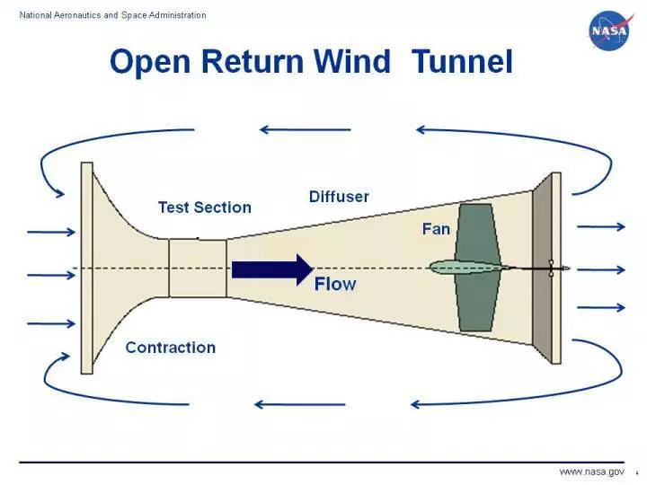

While the sizes and shapes may differ, the important part is that these open-ended wind tunnel draw air into the Contraction Cone and through the Settling Chamber with the fan located at the end of the Drive Section. Students will also need to be sure to include a window for viewing that will be made of plexiglass as well as a door to load their aircraft into the wind tunnel. With the wind tunnels constructed, students will begin the process of establishing their own criteria for testing the planes they’ve created.

**Introduction, Recap**

Use a few moments to recap the lesson from yesterday and pass out the laser cut planes to the teams that made them.

**Tutorial and Activity: Building a Wind Tunnel**

In order to check the performance of their planes, students will create teams of ~four from their pairs and construct a wind tunnel from cardboard, straws, fans, LEDs, and craft plastic.

**Adding Wings**

Students will have approximately 30 minutes to add wings to their planes and test their full plane in their wind tunnel. Although their wing hole will have already been cut, students can experiment with the shaping, direction, and angles at which they want their wings to be attached to the plane. These will be made out of paper. Students will also be able to sand the plane to make fine adjustments to the rigid edges of the plywood. There will be some time left after the break is over to finish any construction. After the wings have been attached, students should look to compare how the water vapor trails flow differently than they did prior to adding the wings. Just like previously, encourage them to experiment with the angle and lighting to see if they can observe and possibly capture pictures and videos of their wind tunnel trails over the plane.

**Presentations**

Before leaving, the student teams will have a short opportunity to go around the room and share the designs that they’ve made with the class. With 25 students, you won’t have much time for each of them to speak, but encourage them to explain the results of the choices they made with the animal they chose and the wing shape they added. Once you’ve gone around the room, make sure to collect the equipment from the wind tunnels including LEDs and fans before the students leave.

Questions to lead with:

* Was turbulence visible in the wind tunnel?
* What changes would they make to their design?
* What do they like most about their choices?
* How did biomimicry inform their decisions?